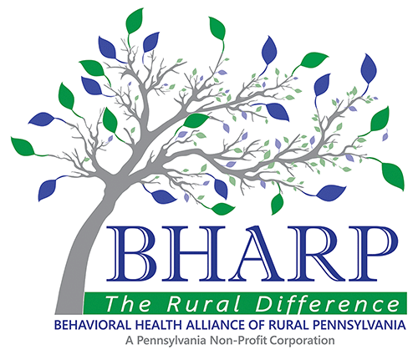


FOR IMMEDIATE RELEASE
Behavioral Health Alliance of Rural Pennsylvania & Community Care Behavioral Health
June 2, 2022

Gaudenzia has been redesignated as a North Central Trauma Informed Care Center for behavioral health services

Sunbury & Berwick, PA: The Behavioral Health Alliance of Rural Pennsylvania (BHARP) and Community Care Behavioral Health Organization announces the achievement of Gaudenzia for their participation in the North Central Trauma Informed Care Initiative at both of their treatment sites located in Sunbury and Berwick.
Sally Walker, CEO of BHARP states that “throughout the global pandemic, mental health needs have been at an all-time high and for Gaudenzia’ s team to have achieved Exemplary status as a trauma site is quite impressive and we appreciate the continued work involved in providing quality care for our members.”
The providers involved in this initiative have expertise in trauma informed care as it pertains to trauma-specific treatment for individuals in care, creating a TIC culture, and promoting safety for staff and individuals. Providers who have made the transition to a TIC environment transformed processes, people, and systems throughout the organization.
Carmine Picarelli, Northumberland County Behavioral Health/IDS Administrator states, “We are blessed to have this level of service in our County for its residents. “ Mary Lyn Cadman, CMSU Behavioral & Developmental Services Administrator shares, “On behalf of CMSU Behavioral Health and Developmental Services, I would like to congratulate Gaudenzia on their accomplishment.”
Dr. Lyndra Bills, Senior Medical Director for Community Care indicates “It is wonderful to see Gaudenzia achieve this status as a TICC provider. This requires ongoing dedication and a real commitment to being able to provide both a trauma informed and trauma specific treatment approach for those who need it.”
If you would like more information, please contact Brenda Fry at bfry@bharp.org

